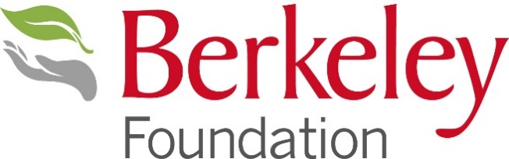

8. Most Impactful Initiative
_______________________________________________________________________________
All entries should answer the specific questions set out below. Please note that there is a word limit of 500 words.
Please save this document to your folders so you can edit it. Once completed, please email to awards@berkeleyfoundation.org.uk
This category recognises a specific initiative delivered by a division in support of the Foundation’s work. The nominated venture should demonstrate positive and tangible outcomes for the children, young people, or communities in which Berkeley Group operates.
The initiative might highlight divisional activity that has supported one of the Foundation’s Strategic Partners, or it could be a specific initiative forming part of your company’s Community Partnership. It could also celebrate a division-led initiative that has engaged the wider business in Foundation activity.

No more than one entry should be submitted per business. Entries should refer to activities taking place between 1 May 2024 and 31 October 2025.
- What was the initiative and how has it supported the Foundation’s work?
[What was the need? Who was involved? When and how was it delivered?]

- What impact has the initiative had on children and young people or the local community?
[This could include the difference you have made to a partner charity, its beneficiaries, or the wider community. Is it likely to leave a legacy or have a longer-term impact?]

- Why does this initiative deserve to be recognised?
[Think about what makes it stand out.]

