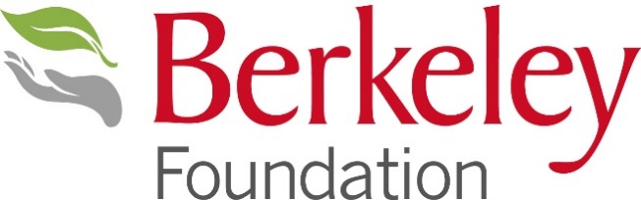

5. Most Impactful Charity Partnership
_______________________________________________________________________________
All entries should answer the specific questions set out below. Please note that there is a word limit of 500 words.
Please save this document to your folders so you can edit it. Once completed, please email to awards@berkeleyfoundation.org.uk
This category will recognise a Berkeley business that has built an outstanding partnership with their Berkeley Foundation Community Partner charity. The entry should demonstrate the aims and objectives, activities and impact of the partnership, including measurable results. Strong entries will include input from the partner charity. The award is more about the activities and participation than the amount raised (although this should be included in the entry).
No more than one entry should be submitted per business. Entries should refer to activities taking place between 1 May 2024 and 31 October 2025.
- Describe your partnership. Please provide some background information on the partnership, and an overview of your plans and activities.
- What has been the impact of the partnership? This could include the difference it has made to a charity, its beneficiaries, the wider community, or the business and staff.
- Why do you deserve to win this award? Think about what makes your partnership stand out.

